8.3 Create First Web Page with Bootstrap
8.5.1 Headings
8.5.2.Display Headings
8.5.3 Inline Text Elements
8.5.4 Text Color and Background
8.5.5 Text Wrapping and Overflow
8.5.6 Font Size
8.5.7 Font Weight and Style
8.5.8 Line Height
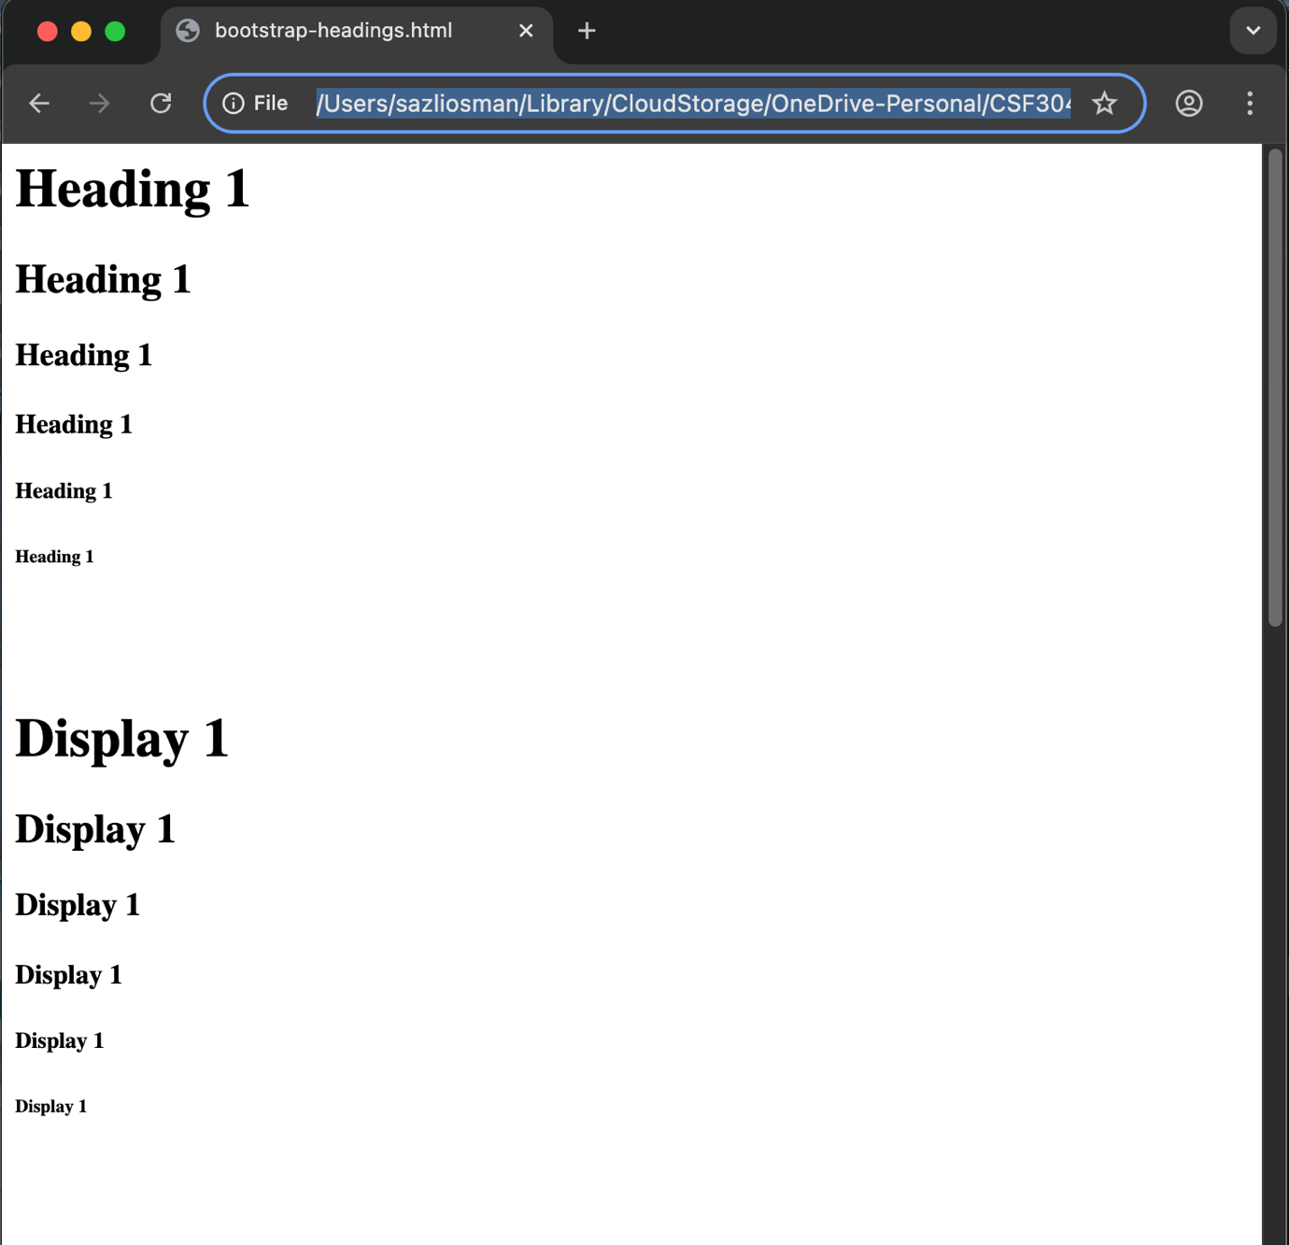
8.5.9 Lists

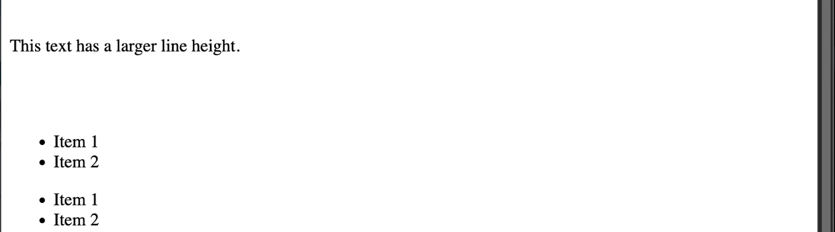
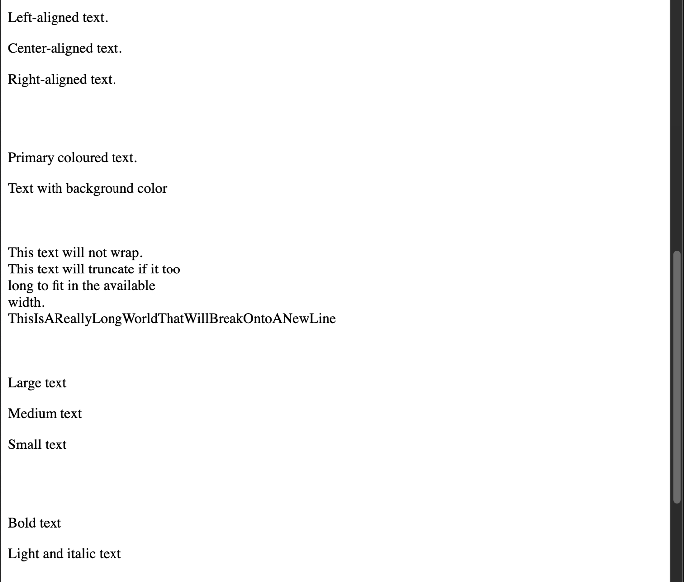

8.6 Bootstrap CSS Forms

